**3. ReactJS-HOL**

**CalculateScore.js:**

import React from 'react';

import '../Stylesheets/mystyle.css';

const percentToDecimal = (decimal) => {

  return (decimal * 100).toFixed(2) + '%';

};

const calcScore = (total, goal) => {

  return percentToDecimal(total / goal);

};

export const CalculateScore = ({ Name, School, total, goal }) => (

  <div className="formatstyle">

    <h1><font color="Brown">Student Details:</font></h1>

    <div className="Name">

      <b><span>Name:</span></b>

      <span> {Name}</span>

    </div>

    <div className="School">

      <b><span>School:</span></b>

      <span> {School}</span>

    </div>

    <div className="Total">

      <b><span>Total:</span></b>

      <span> {total} Marks</span>

    </div>

    <div className="Score">

      <b>Score:</b>

      <span> {calcScore(total, goal)}</span>

    </div>

  </div>

);

**mystyle.css:**

.Name {

  font-weight: 300;

  color: blue;

}

.School {

  color: crimson;

}

.Total {

  color: darkmagenta;

}

.Score {

  color: forestgreen;

}

.formatstyle {

  text-align: center;

  font-size: large;

}

**App.js:**

import { CalculateScore } from './Components/CalculateScore';

function App() {

  return (

    <div>

      <h2>Welcome to Score Calculator App</h2>

      <CalculateScore

        Name="Steeve"

        School="DNV Public School"

        total={284}

        goal={300}

      />

    </div>

  );

}

export default App;

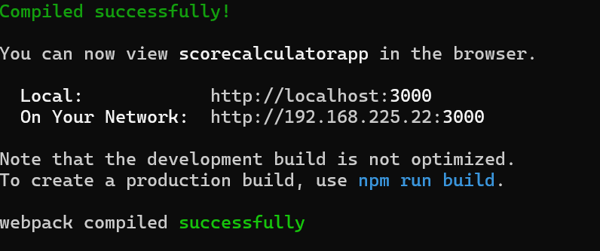

**Output:**

